TASK: 01
PRINTING HELLO WORLD IN C++
Coding | Output
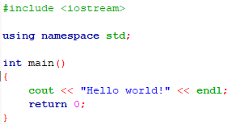 | 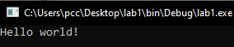
TASK: 02
ADDITION OF 2 NUMBERS IN C++

Coding | Output
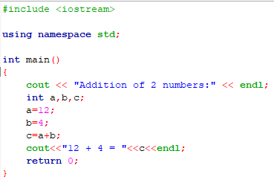 | 